2026 Paper Template for Final Submission
Questions? Please contact The Mentoring Institute at mentor@unm.edu.
This template follows APA 7, with two intentional deviations the editors require: (1) the entire paper, including the reference list, is single-spaced, whereas APA 7 double-spaces; and (2) body paragraphs are flush left with no first-line indent, whereas APA 7 indents the first line. Every other element follows APA 7. This is the final, non-blinded submission version: include your author names and organizations exactly as they should appear in the conference program and the published paper. Replace every [bracketed note] with your own text and delete the note. Read the formatting rules carefully before using the template provided at the end of this document.
Mandatory Sections in Heading Level 1 (APA 7)
Abstract, Introduction, Literature Review, Method/Program/Project/Conceptual Framework (choose one), Results, Discussion, Conclusion, References. Do not merge two sections into one heading. Use these main (Level-1) sections, each as its own APA Level-1 heading (centered, bold, Title Case).
Formatting at a Glance
- Font: Times New Roman, 12 pt for all text — title, headings, body, tables, and references. Margins: 1 inch on all sides.
- Spacing: single-spaced. Paragraphs are flush left with no first-line indentation; do not indent the first line of body paragraphs, and do not justify the text.
- Length: 7 single-spaced pages of content, plus 1 single-spaced page of references, including all charts, tables, figures, graphs, and appendices. Maximum paper length is 8 pages.
- Final submission: this is the final, non-blinded version. Include all author identifiers, and add the author line and the organization line beneath the title (see Title).
- APA 7: citations, references, headings, tables, and figures all follow APA 7.
Do Not Use
Footnotes or endnotes, text boxes or containers, horizontal lines or rules, Word headers or footers, or page numbers. Place all content in normal paragraphs so it can be read and reviewed.
Heading Levels (APA 7)
APA 7 sets headings in Title Case and distinguishes levels by placement and style; never use ALL CAPS.
- Level 1: Centered, Bold, Title Case.
- Level 2: Flush Left, Bold, Title Case.
- Level 3: Flush Left, Bold Italic, Title Case.
- Level 4: Indented, Bold, Title Case, ending with a period. Text begins on the same line.
- Level 5: Indented, Bold Italic, Title Case, ending with a period. Text begins on the same line.
Figures and Tables (APA 7)
- Number: bold and flush left — for example, Figure 1 or Table 1.
- Title: italic, Title Case, on the line directly below the number.
- Note: place any note below the figure or table, beginning with the word “Note.”
- Grayscale: figures and tables must be in grayscale — do not use color fills, colored fonts, or color images. Distinguish data with shades of gray or patterns instead.
- Tables: use horizontal rules only (no vertical lines), as in the example below.
- Insert each table as one complete table (not fragmented rows) and each figure as a single grouped object; give every table or figure a label, a note where needed, and an in-text citation. Any pasted image is treated as a figure (or table) and needs the same.
- Labels and notes outside the image: the figure or table number, title, and note must appear as live text outside the image, never embedded within an inserted image.
- High-resolution images: upload or provide a high-resolution version of every image used.
- AI-generated images: the note must credit the tool, version, and prompt — for example, “Note. Figure generated using [tool] ([version]) from the prompt: ‘[brief prompt].’”
Example: correctly formatted APA 7 table (horizontal rules only — no vertical lines, no color):
Table 1
Doctoral Mentoring Outcomes by Program Format
Program Format | Participants (n) | One-Year Retention (%) | Satisfaction (M)
In-person | 45 | 92 | 4.3
Online | 38 | 85 | 4.1
Hybrid | 52 | 90 | 4.4
Note. Satisfaction was rated on a 5-point scale. Replace this example with your own table.
Example: correctly formatted APA 7 figure (grayscale; the figure number, title, and note are live text placed outside the image, never embedded within it):
Figure 1
Mentoring Program Participation by Format
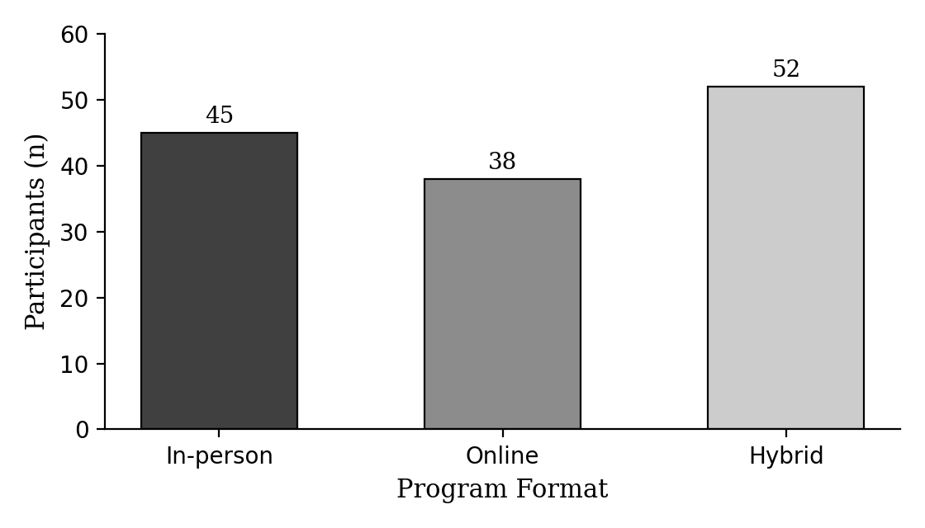
Note. Example figure in grayscale. The label (Figure 1), the italic title, and this note appear as live text outside the image; do not embed them within the image itself. Replace this example with your own figure.
Block Quotations (APA 7)
A quotation of 40 or more words must be a block quotation: start it on its own new line as its own paragraph. Indent the entire block about 0.5 inches from the left margin and do not use quotation marks. End the block with the citation, including the author, year, and page number — for example, (Smith, 2020, p. 5).
Guidelines for In-Text Citations (APA 7)
- Two authors: name both every time — “and” in the sentence, “&” in parentheses.
- Three or more authors: use “first author et al.” from the very first citation (APA 7 — do not spell out all the authors the first time).
- If two different sources would shorten to the same “Surname et al., year,” write out as many author names as needed to tell them apart (for example, “Jones, Smith, Liu, et al., 2020” versus “Jones, Smith, Ruiz, et al., 2020”).
- In the reference list, list every author up to 20; for 21 or more, list the first 19, then an ellipsis, then the final author. “et al.” is not used in the reference list.
Type of Source | Narrative Citation | Parenthetical Citation
Book | Smith and Jones (2020) | (Smith & Jones, 2020)
Course study notes (no author) | “Public Speaker” (2020) | (“Public Speaker,” 2020)
One author | Greenfeld (2020) | (Greenfeld, 2020)
Two authors | Deoliveira and Spates (2019) | (Deoliveira & Spates, 2019)
Three or more authors | Ellenberger et al. (2007) | (Ellenberger et al., 2007)
Group authors | Veteran Affairs (2012) | (Veteran Affairs, 2012)
Same author and year | University (2019a); University (2019b) | (University, 2019a, 2019b)
Multiple sources, one citation | Greenfeld (2020), Scannell (2019), and University (2019a, 2019b) | (Greenfeld, 2020; Scannell, 2019; University, 2019a, 2019b)
No date | Mayo Clinic (n.d.) | (Mayo Clinic, n.d.)
Organization’s website | Centers for Disease Control and Prevention (CDC, 2020) | (Centers for Disease Control and Prevention [CDC], 2020)
Personal communication | M. Smith (personal communication, February 3, 2019) | (M. Smith, personal communication, February 3, 2019)
USE THE TEMPLATE STARTING HERE
[Your Paper Title in Title Case]
[Last, N., Last, N., & Last, N.]
[Organization; Organization]
Instructions: Replace the placeholder with your title, bold and centered, with a maximum of 80 characters (not counting spaces). Use Title Case: capitalize the first letter of each major word (APA 7). Example: “Mentoring Across the Disciplines: A Practitioner Model.” The title must be bold, centered, Title Case, and not italicized.
Because this is the final submission, include author identifiers. On the second line after the title, list the author names in order of co-authorship, formatted as Last, N., Last, N., & Last, N. On the third line, list the organizations in italics, in the same order as authorship, including each organization only once.
Organization naming protocol: remove the article “the”; use the full official name, not an acronym; remove colleges, departments, and similar sub-units; then add a space, a dash, and a space, followed by the campus only. Examples: University of California - Los Angeles; University of Texas - El Paso.
Please note: your title, author names, and organizations will appear in the conference program and in your paper exactly as submitted. Review each entry carefully for typos and errors before submitting.
Abstract
[Placeholder — up to 300 words in a single paragraph.]
Instructions: Abstracts may be edited to improve grammar and concise language before and after peer review. If you modify your abstract from the one submitted with your proposal, be sure to update it in the system (My Conference / Edit My Abstracts).
- Do not include in-text citations in the abstract.
- Do not insert headings within the abstract (for example, “Research:”, “Results:”, “Discussion:”).
- Avoid statements such as “___ is why the paper fits into this year’s theme” or “___ shared in my presentation.”
- Avoid speaking in the first person.
[Keywords: per APA 7, italicize only the label “Keywords:” — the keyword terms themselves are plain text (not italic), lowercase, separated by commas, on the same line and left-aligned immediately after the abstract, to improve the searchability of your paper. Example: Keywords: mentoring, higher education, peer support]
Introduction
[Placeholder — Introduce the key components of the paper. The introduction sets the stage for the study and explains why it is important in the field.]
Literature Review
[Placeholder — Include a literature review describing the existing knowledge base upon which the presentation is built. Include in-text citations and references following APA 7 with DOI links as appropriate. The writing summarizes, synthesizes, and integrates the empirical knowledge in relevant areas. All literature reviewed should have in-text citations and be aligned with the References.]
Method/Program/Project/Conceptual Framework
[Placeholder — Choose ONE heading for this section — Method, Program, Project, or Framework — based on the nature and scope of your paper, and use only that single word (delete the slashes and the unused terms). The author(s) describe(s) the method in such detail that another researcher could duplicate the study. Describe in detail the participants, instruments, and procedures.]
Results
[Placeholder — Describe the data analysis processes and procedures. As appropriate to the study, include a section for descriptive statistics by following the APA 7 style guide.]
Discussion
[Placeholder — Interpret the findings and write about them in the broader context of the literature. Begin with specifics and end with more general statements. Discuss how the findings align with the existing literature. Include the limitations of the study and recommendations for future research, and present theoretical or practical implications.]
Conclusion
[Placeholder — Conclude with a summary that explicitly identifies what works (evidence-based effective practice), for whom (populations), and when (age, career or life stage, and similar factors).]
Acknowledgments (Optional)
[Placeholder — Because this is the final version, include your acknowledgments here. Use them to recognize grant funding and departmental support, and to credit authors and contributors who could not attend. List all acknowledgments in this order: (1) grants and funding; (2) departmental support; (3) individual contributors. Example: The work reported in this publication was supported by the National Institute of General Medical Sciences under award number [GRANT NUMBER]. The content is solely the responsibility of the authors and does not necessarily represent the official views of the NIH. The authors would also like to thank [Name] and [Name] for contributing to this paper.]
Artificial Intelligence (AI) Use Disclosure
Did you use AI in the production of this paper?
Instructions: If you used any AI tool at any stage (for example, drafting, editing, summarizing, coding, or analysis), you must include a brief AI Use Disclosure here, placed after the Acknowledgments and before the References. In no more than 100 words, state (1) the AI model or tool used, (2) the version, (3) how it was used, and (4) a summary of the prompts. If you did not use AI, you may state: “No AI tools were used in the production of this paper.” Please note that the conference targets no more than 10 percent AI-detected content.
Example: The authors used [AI tool] ([version]) to [purpose]. Prompts asked the tool to [brief summary]. All decisions, interpretations, and final content were made and verified by the authors, who take full responsibility for the paper.
Appendix {X} (Optional)
Instructions: If included, place the Appendix before the References, use a Level-1 “Appendix” heading, and keep appendices to a maximum of 2 pages. Note that appendices count toward the 8-page limit.
References
[Placeholder — alphabetical by first author’s surname, with a hanging indent. Authors as “Last name, Initials.” with an ampersand before the final author; article titles in sentence case; journal title and volume in italics; DOI as a link with no spaces.]
Instructions: References must be in APA 7 format. Do not exceed 1 single-spaced page of references (approximately 20–25). 75% of references should be current, and seminal work should be relevant to the article’s premise. Example:
Author, A. A., & Author, B. B. (2020). Title of the article in sentence case. Journal Name, 12(3), 45–60. https://doi.org/10.xxxx/xxxxx
PLEASE, NO FOOTNOTES OR ENDNOTES.

